Software Architecture – Task3
Conceptual sketch

Group – 04:
01616144, Damian Garber
01616154, Alexandra Taupe
01606275, Manuel Doler
01614541, Felix Wallner

Our micro-service architecture for task 4 is composed of three main parts:
The database, the controller and the web server:

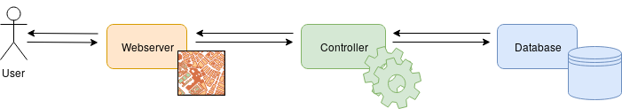
Database:
This will be the database we created in task 1.
The database uses MariaDB as database management system and runs in a docker container already. It keeps the shop, points of interest and favourite information for our application.

Controller:
The controller will be a modified version of our controller from task 2.
It uses java to access and process the data from the database. It will be changed for task 4 to expose an API for communication with the web server.
The API will contain REST Web services for searching, adding, editing a removing shops and favourites.

Webserver:
The web server will provide the interface for the user to interact with the application via a browser.
It will be possible to search for different shops by category, name and/or point of interest.
Eventually we may use different third party APIs for visualization such as maps.
Our current plan is to use NodeJS for this purpose.

